**Java’s Role in AI/ML**

**In the rapidly evolving field of Artificial Intelligence (AI) and Machine Learning (ML), Java stands out as a key enabler and innovator. This programming language, known for its robustness and versatility, has become integral to developing intelligent and data-driven solutions. Across industries, from healthcare to finance, Java's influence in real-world AI applications is both significant and transformative.**

**Its role in these fields is pivotal for several key reasons, making it a top choice for many businesses that are at the forefront of technological innovation.**

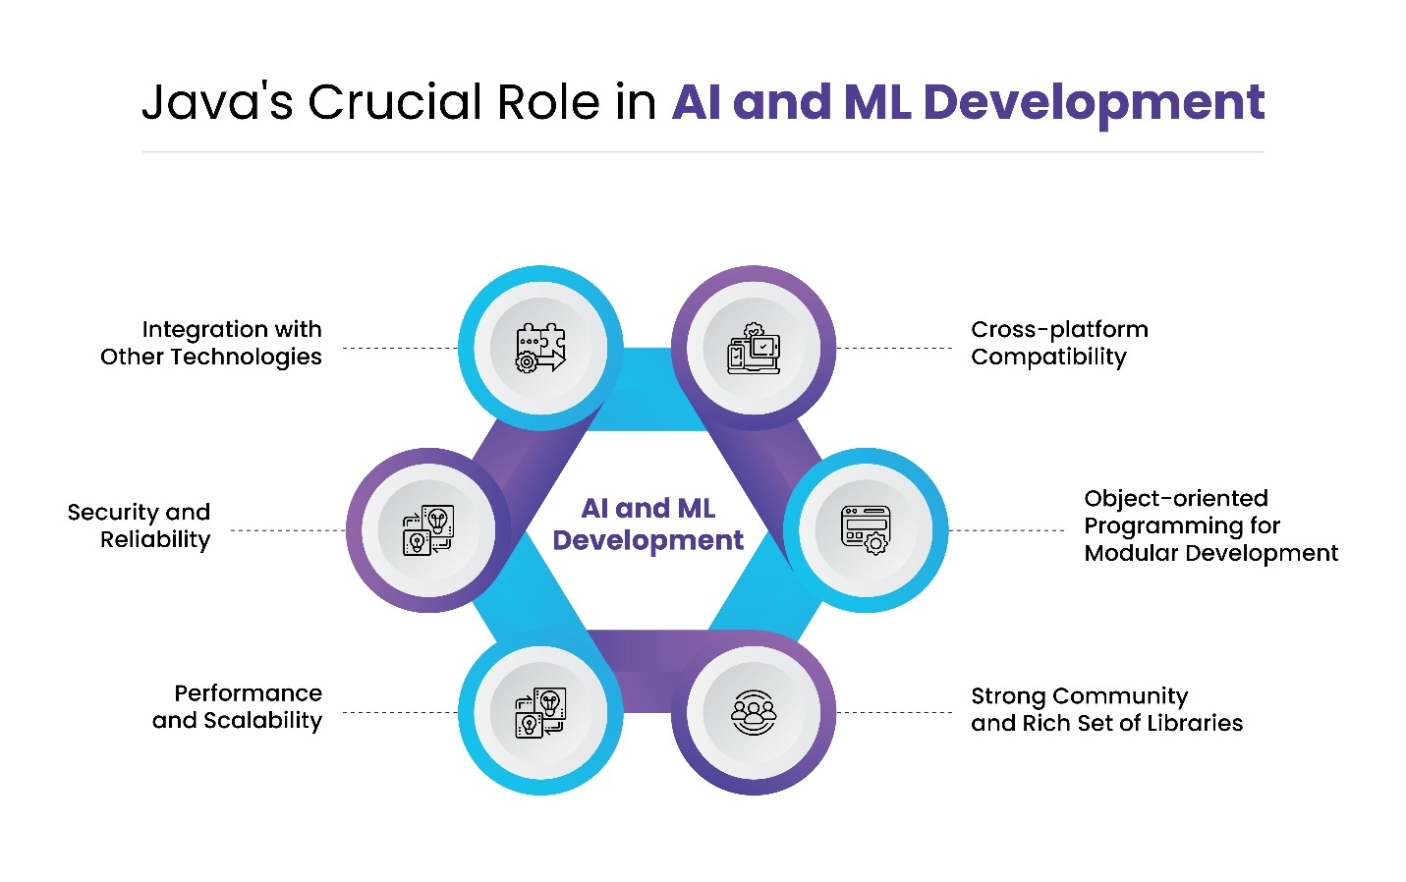

**Java’s Crucial Role in AI/ML Development:**

1. **Simplicity and Readability**: Java's straightforward syntax makes it accessible for AI/ML developers.
2. **Cross-platform Capability:** Java's "write once, run anywhere" feature ensures seamless deployment across systems.
3. **Robust Standard Library:** Offers rich libraries for data handling, networking, and multithreading essential for AI/ML tasks.
4. **Memory Management:** Automatic garbage collection enhances efficiency and reduces memory leaks.
5. **Scalability and Performance:** Supports large-scale, high-performance AI/ML applications with multithreading and distributed computing.
6. **Strong Community Support:** The extensive developer community provides resources, frameworks, and tools for AI/ML development.
7. **Security Features:** Built-in security mechanisms protect sensitive data in AI/ML systems.
8. **Versatility and Integration:** Easily integrates with big data tools, databases, and other programming ecosystems for AI workflows.

**Real-world Applications of Java in AI/ML:**

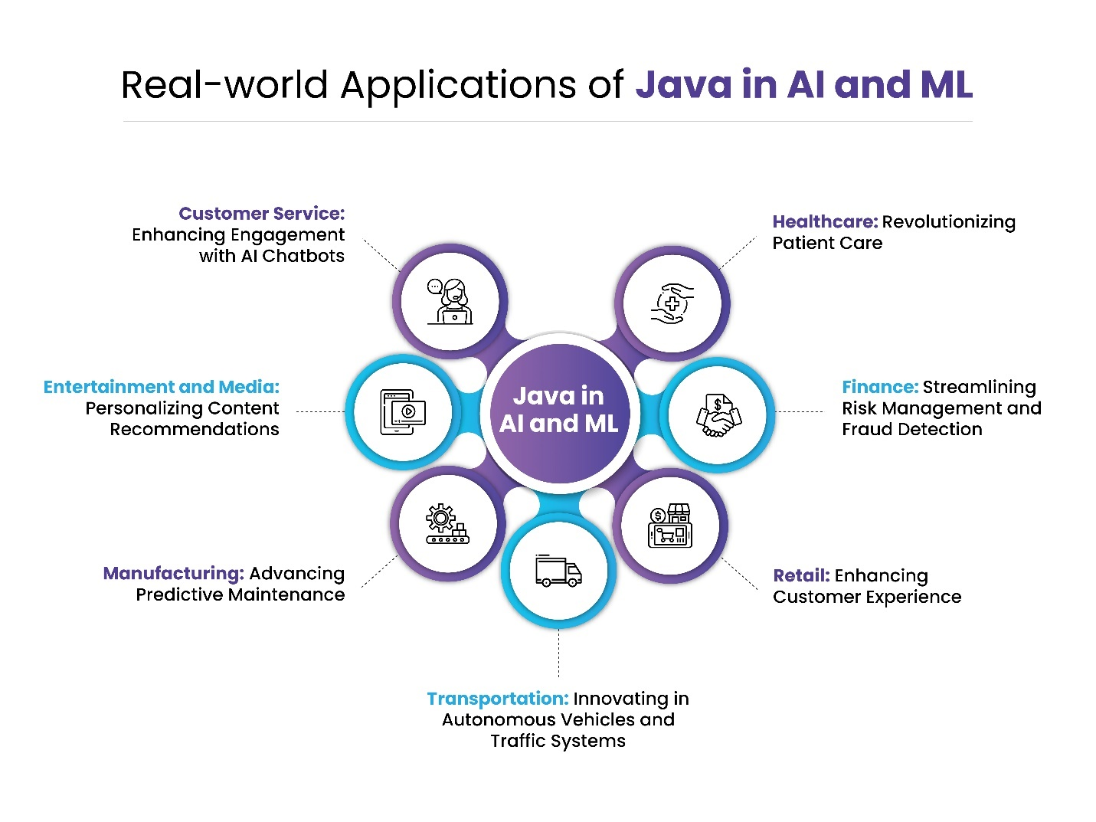

1. **Healthcare: Revolutionizing Patient Care**

* Driven solutions like IBM Watson Health, which leverages medical data analysis to support diagnostics and treatment, enhancing decision-making and patient outcomes.

1. **Finance: Enhancing Risk Management and Security**
   * Java powers AI systems like those at JPMorgan Chase, using ML algorithms to detect fraud and assess risks in real-time by analyzing transaction patterns, boosting security and trust.
2. **Retail: Enhancing Customer Experience**
   * Amazon uses Java-powered AI to analyze customer behavior, delivering personalized product recommendations that improve shopping experiences and drive sales.
3. **Transportation: Innovating in Autonomous Vehicles and Traffic Systems**
   * In transportation, Java's contributions are notable in developing self-driving car technologies and traffic management systems. Java's real-time processing capabilities are vital for the split-second decision-making required in these systems.
4. **Manufacturing: Advancing Predictive Maintenance**
   * In manufacturing, Java-based AI and ML are employed for predictive maintenance, as seen in Siemens' use of Java for its digital industry software. This software uses Java-powered AI algorithms to predict equipment maintenance needs, thereby reducing downtime and optimizing production efficiency.
5. **Entertainment and Media: Personalizing Content Recommendations**
   * Java's AI capabilities also significantly impact the entertainment and media industry, particularly in content recommendation systems. Netflix's recommendation algorithm, powered by Java, analyzes viewer preferences to suggest movies and TV shows, thereby enhancing user engagement and satisfaction.
6. **Customer Service: Enhancing Engagement with AI Chatbots**
   * In customer service, Java-driven AI chatbots and virtual assistants are increasingly prevalent. A notable example is the AI chatbot solutions provided by LivePerson, which utilizes Java to deliver efficient and intelligent customer interaction capabilities, improving overall user experience.

**Leading Machine Learning Libraries for Java**

**1. Weka**

* **Description**: Weka (Waikato Environment for Knowledge Analysis) is a collection of machine learning algorithms for data mining tasks.
* **Features**:
  + Built-in algorithms for classification, regression, clustering, and feature selection.
  + Easy-to-use graphical user interface (GUI) for quick experimentation.
  + Integration with Java code via APIs.
* **Use Cases**: Educational purposes, prototyping, and simple ML tasks.
* **Website**: [Weka](https://waikato.github.io/weka-wiki/)

**2. Deeplearning4j (DL4J)**

* **Description**: A deep learning framework for Java and Scala that supports distributed computing.
* **Features**:
  + GPU support for faster computation.
  + Integration with Apache Spark for distributed deep learning.
  + Pre-trained models and tools for neural networks.
* **Use Cases**: Building deep learning models for image recognition, natural language processing, and more.
* **Website**: [Deeplearning4j](https://deeplearning4j.konduit.ai/)

**3. Smile (Statistical Machine Intelligence and Learning Engine)**

* **Description**: A fast and comprehensive machine learning library for Java.
* **Features**:
  + Covers a wide range of ML algorithms (classification, regression, clustering, etc.).
  + Visualization capabilities.
  + Support for natural language processing (NLP) and graph analysis.
* **Use Cases**: General-purpose machine learning and statistical tasks.
* **Website**: [Smile](https://haifengl.github.io/)

**4. Apache Mahout**

* **Description**: A distributed framework for scalable machine learning.
* **Features**:
  + Built on Apache Hadoop for distributed computation.
  + Focuses on collaborative filtering, clustering, and classification.
  + Integration with Apache Spark and Flink.
* **Use Cases**: Big data machine learning applications.
* **Website**: [Apache Mahout](https://mahout.apache.org/)

**5. MOA (Massive Online Analysis)**

* **Description**: A framework for online learning and data stream mining.
* **Features**:
  + Specializes in handling streaming data.
  + Real-time classification, regression, clustering, and frequent pattern mining.
* **Use Cases**: Applications where data arrives continuously, such as IoT and real-time analytics.
* **Website**: [MOA](https://moa.cms.waikato.ac.nz/details/)

**6. Java-ML**

* **Description**: A lightweight and modular machine learning library.
* **Features**:
  + Implements basic ML algorithms (classification, clustering, feature selection).
  + Easy integration into Java projects.
  + Focuses on simplicity and ease of use.
* **Use Cases**: Educational purposes and small projects.
* **More info**: [Java-ML](https://www.jmlr.org/papers/volume10/abeel09a/abeel09a.pdf)

**7. H2O.ai**

* **Description**: An open-source platform for scalable machine learning.
* **Features**:
  + Distributed and parallelized ML algorithms.
  + AutoML for automatic model generation and tuning.
* **Use Cases**: Scalable ML solutions, especially in finance and healthcare.
* **Website**: [H2O.ai](https://docs.h2o.ai/h2o/latest-stable/h2o-docs/faq/java.html)

**8. Tribuo**

* **Description**: A recent ML library designed specifically for Java.
* **Features**:
  + Built-in support for classification, clustering, and regression.
  + Focuses on explainability and reproducibility of models.
  + Interoperability with TensorFlow models.
* **Use Cases**: General-purpose machine learning with a focus on modern Java APIs.
* **Website**: [Tribuo](https://tribuo.org/learn/4.3/docs/)

1. **TensorFlow Java**

* **Description**: TensorFlow Java is the official Java API for TensorFlow, one of the most popular deep learning frameworks..
* **Features**:
  + Provides a graphical interface and Java integration.
  + Tools for preprocessing, modeling, evaluation, and deployment.
* **Use Cases**: **Use Cases**: Real-time inference in enterprise systems, IoT, healthcare, and mobile app.
* **Website**: [TensorFlow](https://www.tensorflow.org/jvm)

**Choosing the Right Library:**

* **For Beginners:** Start with Weka or Java-ML.
* **For Deep Learning:** Use Deeplearning4j or H2O.ai.
* **For Big Data:** Choose Apache Mahout or H2O.ai.
* **For Online/Streaming Data:** Use MOA.

Each library has its strengths, so the choice depends on your project's requirements.

**Roadmap:**

**1. Week 1: Core Java and ML Basics**

**Day 1-2: Java Refresh**

Review OOP concepts, multithreading, and collections.

Practice file handling and Java Streams.

**Day 3-4: ML Fundamentals**

Study basic ML concepts (e.g., supervised vs. unsupervised learning, evaluation metrics).

Watch tutorials or read introductory materials on machine learning.

**Day 5-6: Setup Environment**

Install JDK, IDE (e.g., IntelliJ IDEA/Eclipse), and Maven/Gradle.

Set up libraries like Weka and RapidMiner.

**Day 7: Data Preprocessing with Weka**

Use Weka’s GUI to preprocess datasets (e.g., scaling, filtering).

Try basic classifiers like Decision Trees and Naive Bayes.

1. **Week 2: Explore Entry-Level Libraries**

**Day 8-9: Weka Java API**

Write Java code to load datasets and apply ML algorithms using Weka.

Experiment with classification and clustering tasks.

**Day 10-11: RapidMiner Basics**

Explore the RapidMiner GUI to create data workflows.

Try out basic models like regressions and k-means clustering.

**Day 12: RapidMiner Java API**

Write Java code to integrate RapidMiner into a sample project.

**Day 13-14: Build a Small Project**

Implement a simple project (e.g., spam classification or sentiment analysis) using Weka or RapidMiner.

1. **Week 3: Real-Time and Large-Scale AI**

**Day 15-16: MOA for Online Learning**

Learn to process data streams in MOA.

Train models on evolving data (e.g., sliding window).

**Day 17-18: Apache Mahout Basics**

Set up Mahout with Hadoop (or standalone).

Practice clustering and recommendation tasks.

**Day 19-20: Distributed Processing**

Experiment with running Mahout algorithms on large datasets.

1. **Week 4: Neural Networks and Advanced AI**

**Day 21-22: Encog Basics**

Build simple neural networks using Encog.

Explore genetic algorithms for optimization.

**Day 23-25: Deeplearning4j (DL4J)**

Install DL4J and explore basic neural network configurations.

Practice using pre-built models for classification and regression.

**Day 26-27: TensorFlow Java**

Learn to load and run pre-trained TensorFlow models.

Experiment with TensorFlow Lite for mobile or IoT applications.

1. **Week 5: Integration and Deployment**

**Day 28-29: Combine Libraries**

Integrate multiple libraries in a single project (e.g., preprocessing with Weka, model inference with TensorFlow Java).

**Day 30: Deploy a Mini-Project**

Build and deploy an end-to-end project, such as a recommender system, fraud detection tool, or predictive maintenance app.

Step 1: Refresh Java Concepts

Step 2: Learn basic ML Fundamentals

Step 3: Explore Entry Level ML libraries  
Step 4: Learn their Integration

Step 5: Build and deploy a project